Brown ES 1st Grade Supply List

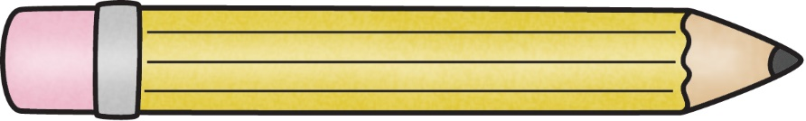

**$25 Class Fee:** to be used for additional classroom supplies and art materials throughout the year

(Checks made out to Brown Elementary)

**Personal supplies that should be labeled with student’s name and placed in pencil box**

* Plastic (**8x5x2**) pencil box/case (Please no “lock and key” type cases, remember they must fit inside a desk. The $1 ones work great!**)**
* **Fiskars** scissors
* Crayola markers (8-10ct)
* 1 Water bottle that will be filled at home each day

**Community supplies: Please DO NOT label these items**

* 1 pack of yellow sharpened **Ticonderoga** pencils (non-decorative)
* 1 plastic 2 pocket folder
* 1 package (4-6 ct.) glue sticks
* 2 boxes of **Crayola** 24 pack crayons
* 8 black **EXPO** dry erase markers
* 1 ream of copy paper
* Boys: Baby wipes **or** Clorox wipes
* Girls: 1 box or tissue **or** sandwich baggies

Optional/Appreciated Supplies

The contribution of one or more of these supplies is **completely optional** and simply helps us throughout the year!

* Watercolor kit
* Colored copying paper or cardstock
* Thermal laminating sheets
* Clear sheet protectors

**\*Classroom teachers may request different/additional supplies once school begins\***